1.8 Integrating with Selenium WebDriver: Script

This section will guide you:

* To integrate using Selenium WebDriver - Script

**Development Environment:**

* Apache JMeter 5.1.1 Version
* OpenJDK Runtime Environment 11.0.2

This guide has five sub-sections, namely:

1.8.1 Installing Plugins Manager and configuring it to JMeter

1.8.2 Installing WebDriver plugin

1.8.3 Writing a WebDriver Script

1.8.4 Running WebDriver tests in JMeter

1.8.5 Pushing the code to your GitHub repositories

**Steps 1.8.1:** Installing Plugins Manager and configuring it to JMeter

* Download WebDriver plugins for JMeter.
* Download the JMeter Plugin from: “<https://jmeter-plugins.org/install/Install/>”.

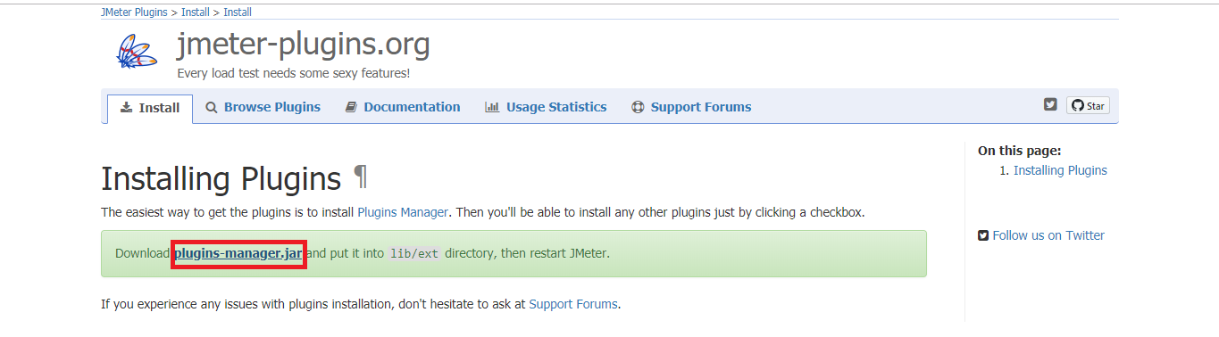

* Unzip JMeterPlugins-WebDriver 1.1.3 (version is default).
* The unzipped files must be copied into the lib folder -> ext folder of JMeter.

**Steps 1.8.2:** Installing WebDriver plugin

* Select Options --> click on Plugins Manager.

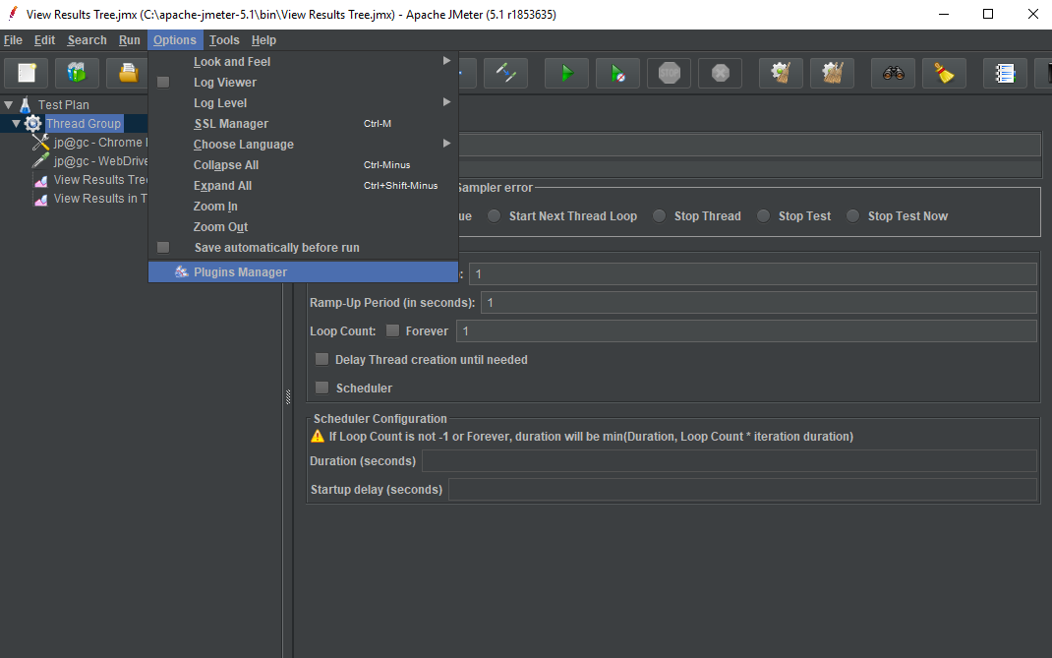

* Click on the Available Plugins. Now, click on the Selenium/WebDriver Sampler.
* Click on Restart and the Install button. (JMeter will automatically restart).
* Click on install plugins and then click on Selenium/WebDriver Sampler.

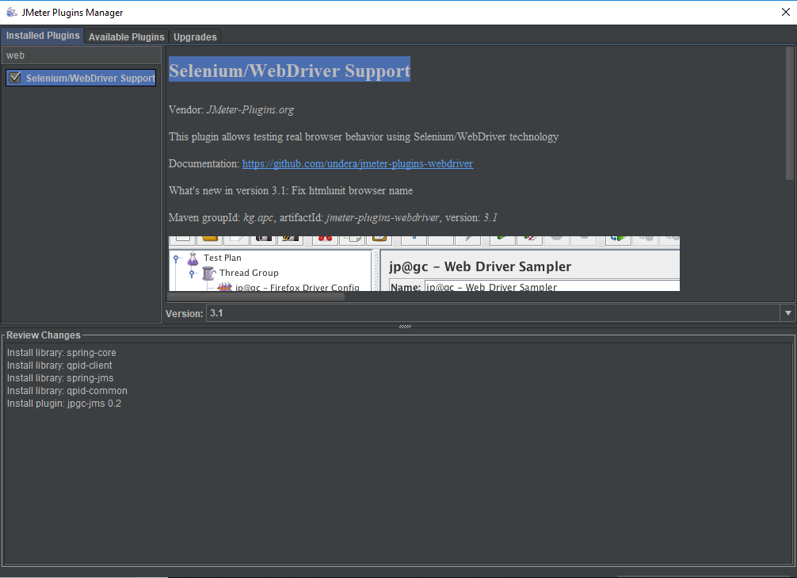

**Steps 1.8.3:** Writing a WebDriver Script

* Right click on Test Plan.
* Click on Add -> Thread(Users) -> Thread Group.

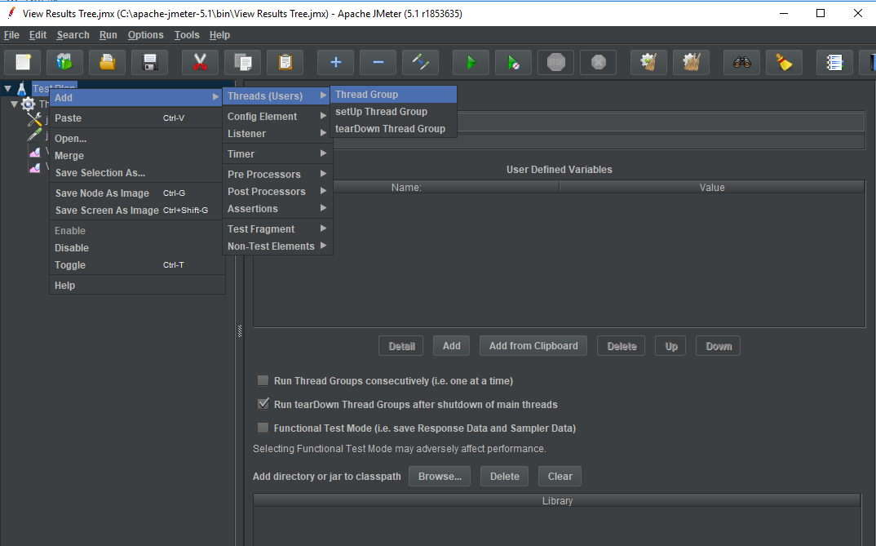

* Right click on Thread Group.
* Click on Add -> Config Element -> jp@gc Chrome Driver Config.
* You can also use the Firefox Driver for this.
* Click on Add ->Config Element ->jp@gc Firefox Driver Config.

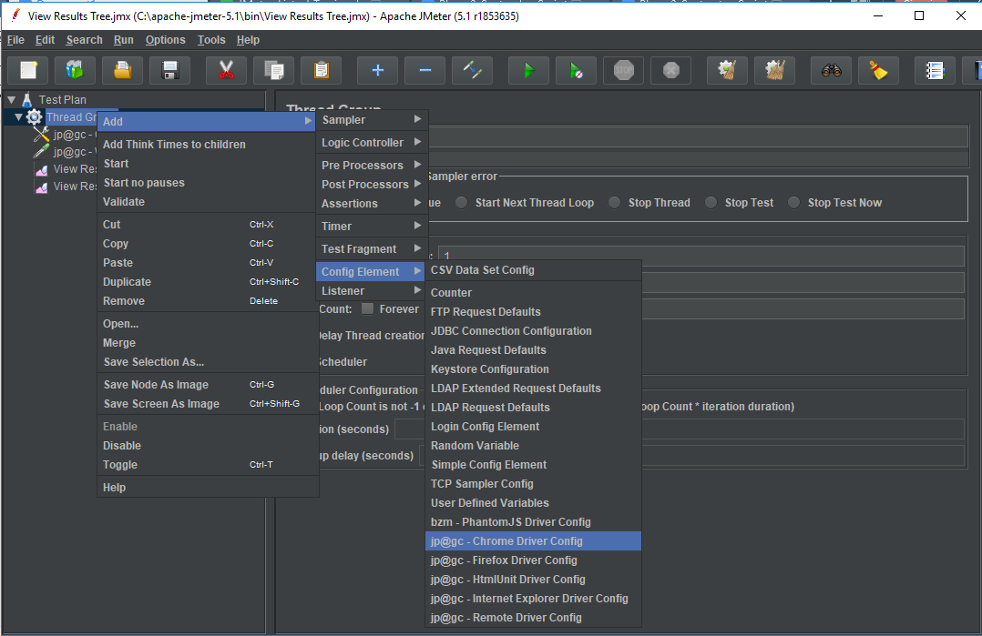

* Right click on Thread Group.
* Click on Add -> Sampler -> jp@gc WebDriver Sampler.

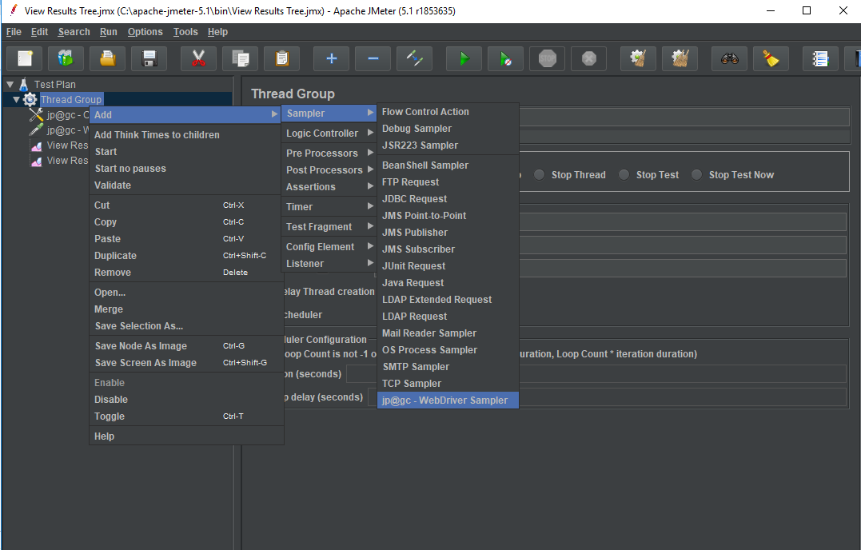

* Right click on Thread Group.
* Click on Add -> Sampler -> Listener-> View Results Tree.

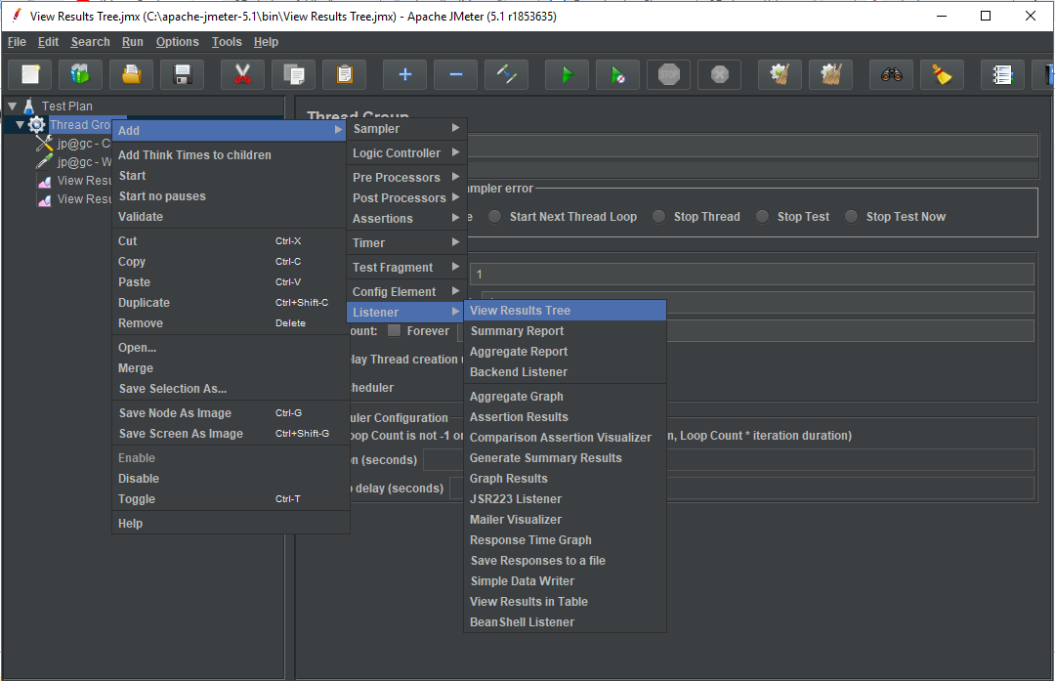

**Steps 1.8.4:** Running WebDriver tests in JMeter

* Click on jp@gc Chrome Driver Config.
* Enter your Driver path.
* You can also use Firefox Driver Config.
* Enter your Driver path.

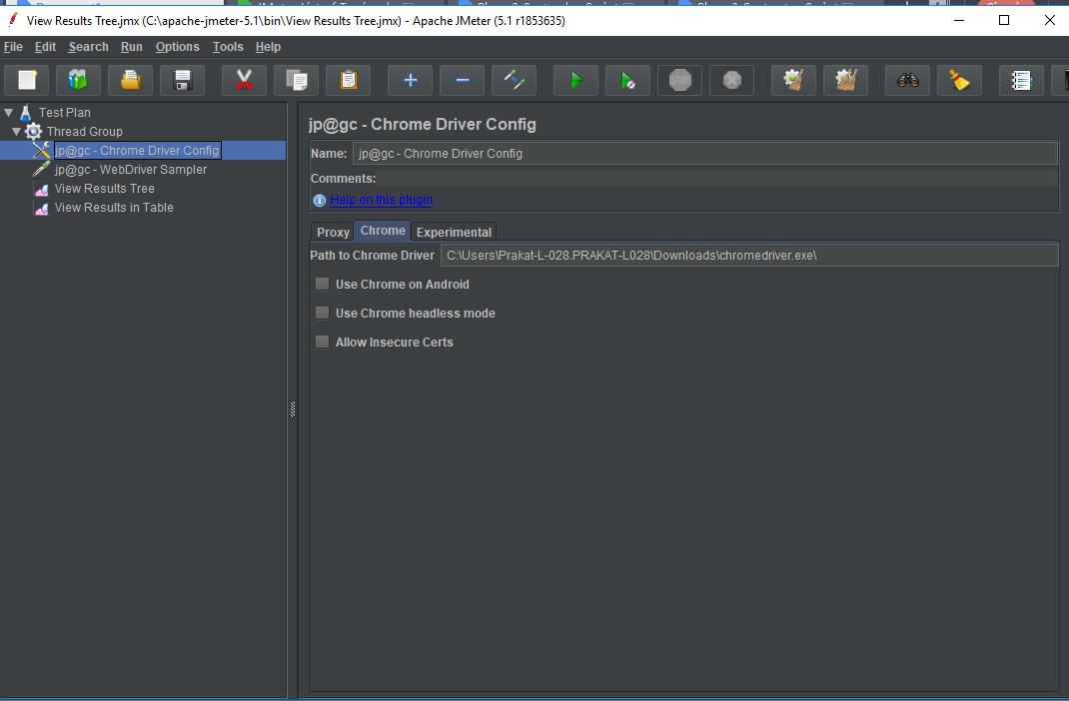

* Click on jp@gc WebDriver Sampler.
* Write the Selenium script.

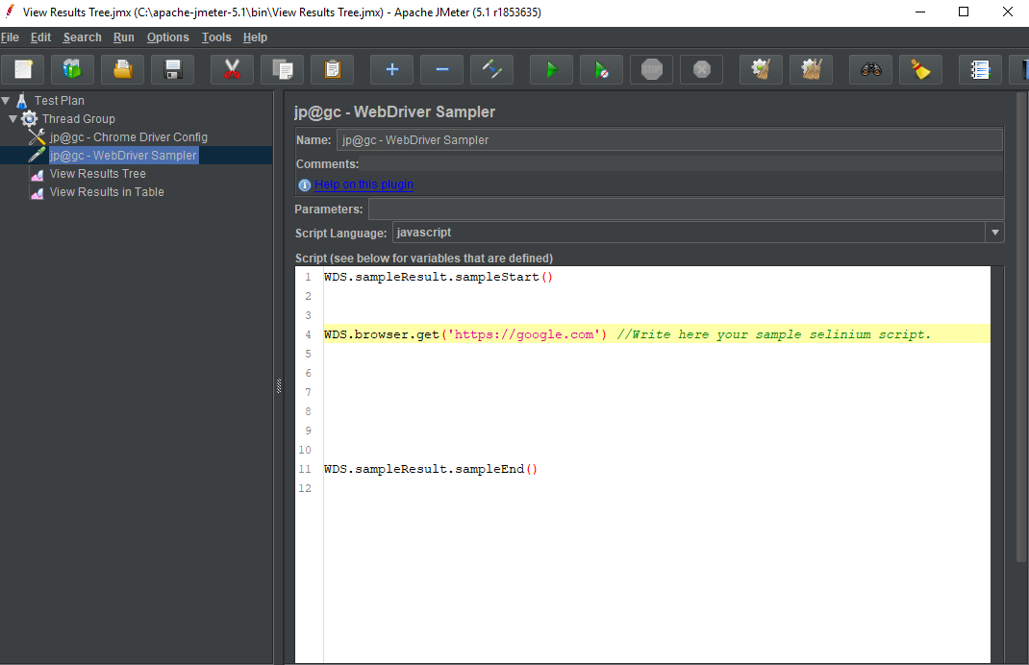

* Run the script.
* View the results in **View Result Tree**.

**Step 1.8.5:** Pushing the code to GitHub repositories

Open your command prompt and navigate to the folder where you have created your files.

cd <folder path>

Initialize your repository using the following command:

git init

Add all the files to your git repository using the following command:

git add . 

Commit the changes using the following command:

git commit . -m “Changes have been committed.”

Push the files to the folder you initially created using the following command:

git push -u origin master